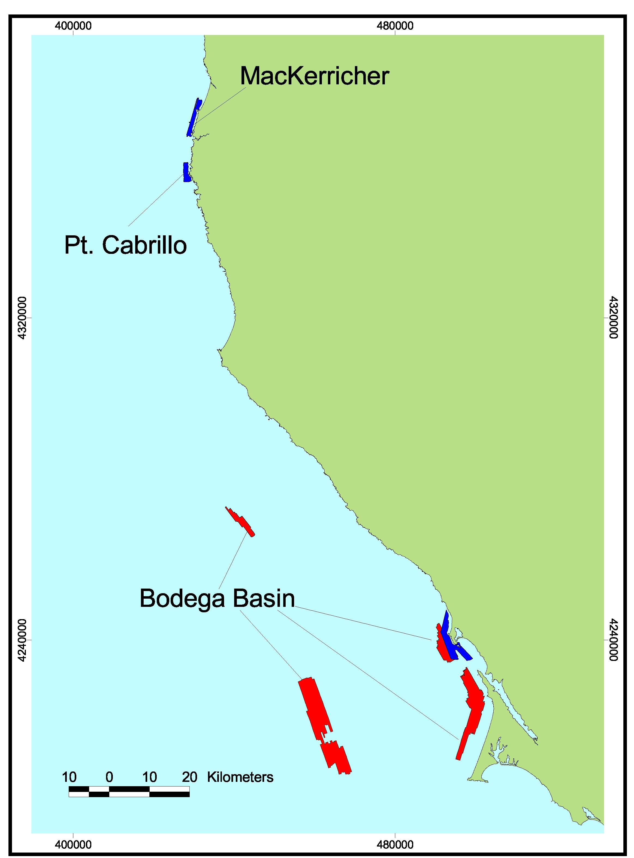
Footprint Map of Northern Region A. Regions included in this volume were either surveyed by CSUMB (Bodega Basin, Pt. Cabrillo, and MacKerricher – blue) using multibeam imagery or by industry (Bodega Basin – red) using sidescan sonar imagery and mapped by the Center for Habitat Studies.

